APGF Secretariat Report – November 2015

This month kicked off with a number of exciting new developments for the APGF.

Starting with our first AGM, following the adoption of the new Constitution, at the end of October. A huge thank you to everyone involved in the AGM – to Margaret Blakers for hosting us on Webex, and all those who put themselves forward for roles. We have two passionate and experienced Co-Convenors in Liaquat Ali Shaikh and Georgina Morrison., as well as a Council with a huge collective knowledge for the region and APGF.

Our APGF intern Saima Gul had her first month on the job – and has managed to pull together a newsletter, which will be shared amongst APGF shortly, as well as organising a climate and women’s political action in Pakistan. Wonderful effort from Saima – her report will be included at the end of this report.

The APGF-IDC progressed the small grant proposals – and thanks to the generosity of the Australian Greens IDC, we are happy to announce that four applications have been successful – Philippines, Pakistan, Indonesia, and the Solomon Islands. Our new practice will be to form working groups with those parties, the APGF and the IDC to help assist these projects.

Our November Council meeting was held successfully via skype. Nominations for positions on the Council’s Management and Coordination Committee (MAC), treasurer, webmaster, and APGF rep to Global Greens are open until December 10th – so if there are interested persons in your country, please get in touch, Claire.waghorn.apgn@gmail.com
The Council also appointed a Membership Committee to start reviewing the backlog of membership applications to the APGF – special thanks to Robin, Suresh, Bob Hale and Georgina. We have good regional coverage and tremendous experience of green politics within this group.

Collective actions from our APGF parties and friends have seen mass participation in the global climate marches around the region – it is wonderful to have such a collective focus that we can all participate in. There is much work to be done over the next two weeks in relation to supporting our Greens in Paris.

Finally, the ‘Secretariat’ will be closing for two weeks over the Christmas period. The Council has chosen to cancel the December meeting, and our next meeting will be held in January.

Kind wishes to you all,
Claire

APGF Secretary

Secretariat Expenses for November 2015

There has been one additional expense for November - AUD $16 skype credit for making phone calls, as our November call required a call to a landline, as well as the usual internet based calls.

APGF AGM | Circulate minutes and update of AGM to region
APGF Trainee | Give Saima first tasks and expected reporting requirements
APGF Secretariat | Create mailing list for Council and Members
APGF website | Update website with AGM outcomes i.e. Councillors and Co-Convenors, new positions
APGF Secretariat | Work with Keli to support handover from her to new Co-Convenors
APGF Secretariat | Welcome new members, and thank former members
APGF Council | Organise meeting time, and support Convenors for first meeting agenda
APGF Secretariat | Faciliate handover between former and newly elected APGF Convenors
APGF Secretariat | Advertise new positions that need to be filled and share with all regional contacts
APGF Secretariat | Respond to Taiwanese media request about Congress resolution to recognise Taiwan independence
APGF Project Grants | Shortlist and conversation with Evan about next steps
APGF Project Grants | Update all applicants on status of their project proposals - successful and unsuccessful
Project - Solomons | First working group meeting, and ideas to Caroline in advance of her trip to Honiara
Project - Philippines | First and second working group meetings with Bob Muntz, Kiko and Gloria
APGF Project Grants | Give meaningful feedback to those projects that missed out.
APGF Membership | Respond to new requests and share previous applications with newly formed membership committee
APGF dates | work on 2016 calendar of events for APGF
APGF Council | Host Council November meeting, and circulate minutes, and action items following.

APGF Trainee Report

Month: Nov 2015
Report Submitted By: Saima Gul (APGF Trainee)

Outlines
Work done in the month of Nov 2015
- Started from the searching of APGF member countries websites, visited all member countries websites but only few countries have updated websites other all members countries websites are not updated and I could not found any update their but few.
- Searched Face book Pages of all countries but only found four on Facebook, Pakistan Green Party, Germany Green Party, India Green Party, and Japan Green Party
- Contacted by Email to all APGF members, Councilors, and conveners and requested them to contribute/ participate in News letter which specially focusing on Climate change issues, women rights and youth issues in your surroundings.
- Collected some material by 3 countries members, Japan, New Zealand and Indonesia and Pakistan
- Drafted Newsletter
- Session on Climate Change and Women Rights
- Organized Session on Climate change with youth of different areas, and organized demonstration in front of press club of district.
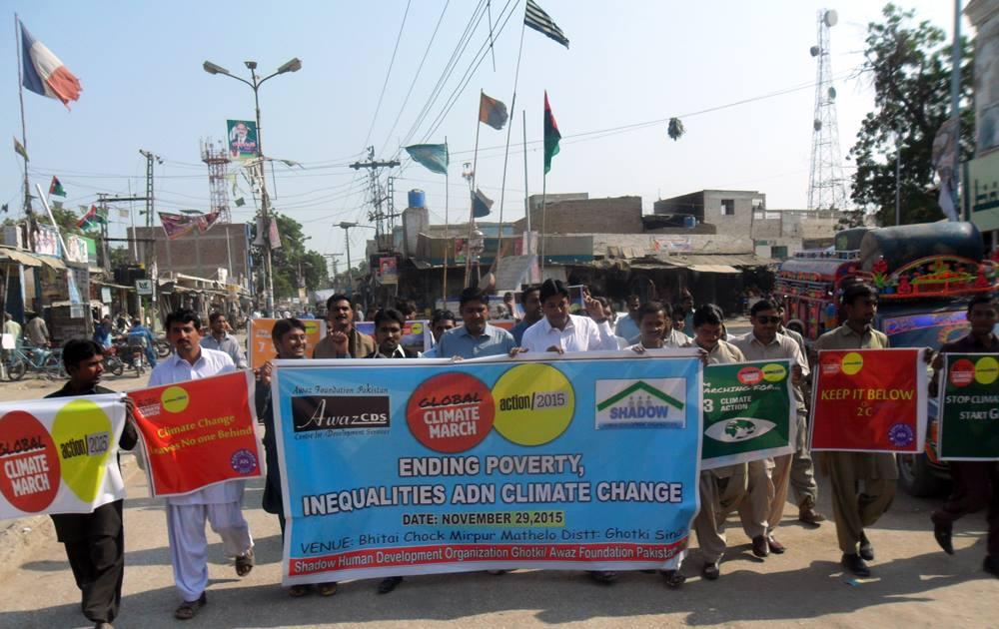
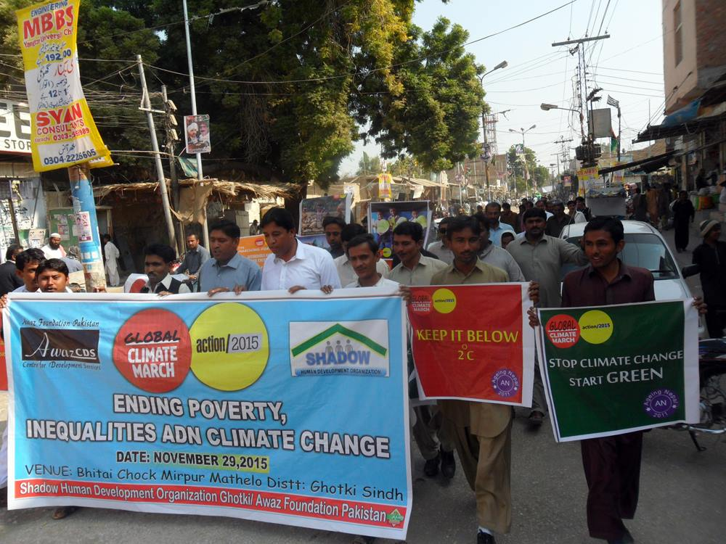
Organized a Seminar on the theme of 16 days of activism the main focusing issue was raise “Stop Killing Women on the name of honor killing”
60 women from rural areas have actively participated and shared their lives stories, and advocated, civil society and media persons have joined and we arranged a walk rally to press club and raised issues of rural women.

