APGF Annual Report 2021

APGF Women’s Network

APGFWN recognizes there are barriers to establishing gender equity in green party politics. The Network endeavors to create a political culture that is inclusive and ready to view green issues from gender-sensitive perspectives by supporting and empowering green women in the Asia-Pacific region.

About APGF Women's Network

APGFWN was formed in November 2015 with 18 members from the Asia-Pacific region. The Network recognizes that ensuring equal opportunities and adequate foundation for women and gender minorities to participate in green politics is of paramount importance for establishing gender equity in Green Parties in the Asia-Pacific. Women's work, position, contribution, and situation should be recognized in all activities of Green Party politics. APGFWN has been, and will continue to, support women by providing programs and materials that assist, empower, and inspire them to stand against patriarchy and voice their agendas in solidarity with other minority groups in our region.

APGFWN Members

Australia, Bangladesh,, India, Indonesia, Iraq, Japan, Jordan, Korea, Lebanon, Mongolia, Nepal, New Zealand, Pakistan,, Philippines, PNG, Solomon Islands and are the members of APGFWN. Green women and women's groups of new APGF members and emerging green parties are invited to contact and join the Network.

APGFWN Executives

Co-convenors: Soohee Lee & Alpyu Singh
Co-secretaries: Minami Teramae & Rachana Shresthra
Treasurer: Suin Yoon
APGFWN rep to GGWN: Anita Nautiyal

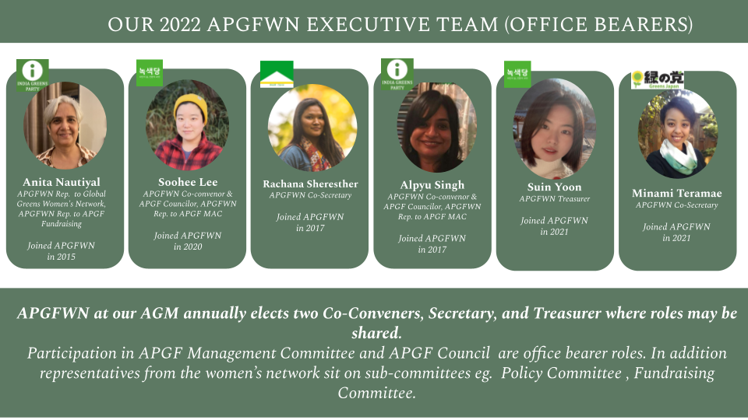

What We Do
APGFWN hosts monthly online meetings and conducts different events and trainings to promote women's issues and discuss about the ways forward for green women in our region. The primary objective of the monthly meeting is to gather information on the agendas and events our members are engaged in at the moment, and search for and work together on possible collaboration and means to support between the Network and the members.

Addressing Gender Equity within APGF
In collaboration with the APGFWN IDC project team, APGFWN participated in conducting the APGF Gender Equity Review of the last three years from 2018 to 2021. APGFWN and the IDC project team collected and analysed the data on gender equity submitted by APGF member parties. The analysis found that most of the parties recognize the importance of gender equity but they each have their own cultural, social, and political barriers to establishing the value in their parties. APGFWN will work closely with APGF to encourage each APGF Member party to respect and enshrine the principle of gender equity in their party constitution and policies.

Strengthening the Network

APGFWN has worked closely with the APGFWN IDC Project Team to assist our members in advancing women's role in their respective green parties. A way to do that is to help local and national green parties to establish a women's wings and provide them the means to initiate their own projects and work. Several member countries and districts have reported promising signs such as initiating their own local gender-related programs and fostering local gender equity trainers.

APGFWN Training and Internship
In the year 2021, APGFWN organised its first Project Management Training and the Next Mentor internship program. Project Management Training invited a trainer from Pathways Australia, a professional training provider. The training was offered, as a part of skills development initiative of the Network, to a limited number of participants whose work in green parties and movement involved project management. In addition, the Network explored a new possibility to encourage green women to engage in green politics with the launch of the Next Mentor internship. The internship aims to offer scholarship and apprenticeship to green women who aspire to build and strengthen their local and national women's wing and their work.

